**FY B.Tech Computer Engineering**

**2020 Course**

**Computational Science**



**VISHWAKARMA INSTITUTE OF INFORMATION TECHNOLOGY, PUNE**

**COMPUTER ENGINEERING DEPARTMENT**

**BY:**

**NAME: Prajwal Waykos**

**G.R NO.: 22010591**

**ROLL NO.: 4036**

**CLASS: FY**

**BATCH: D2**

# EXPERIMENT NO. 7

**Aim: Spectrophotometric or Colorimetric Estimation of Fe+3 from a given solution.**

:

1. **Determination of λmax**

Concentration of solution = 0.005 mg/ml

|  |  |  |
| --- | --- | --- |
| Filter No. |  | Absorbance (A) |
| 1. | 400 | 0.03 |
| 2. | 420 | 0.14 |
| 3. | 470 | 0.32 |
| 4. | 500 | 0.35 |
| 5. | 530 | 0.30 |
| 6. | 620 | 0.05 |
| 7. | 660 | 0.03 |
| 8. | 700 | 0.01 |
|  |  |  |

**Graph I: (1 Mark+2Marks))**

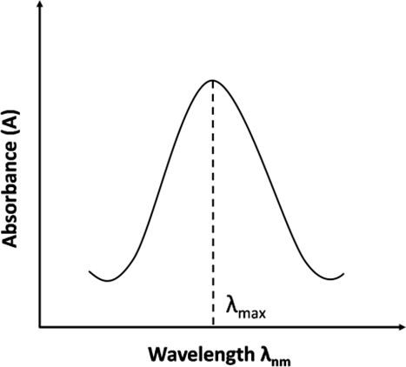

From graph I , λmax = 500 nm

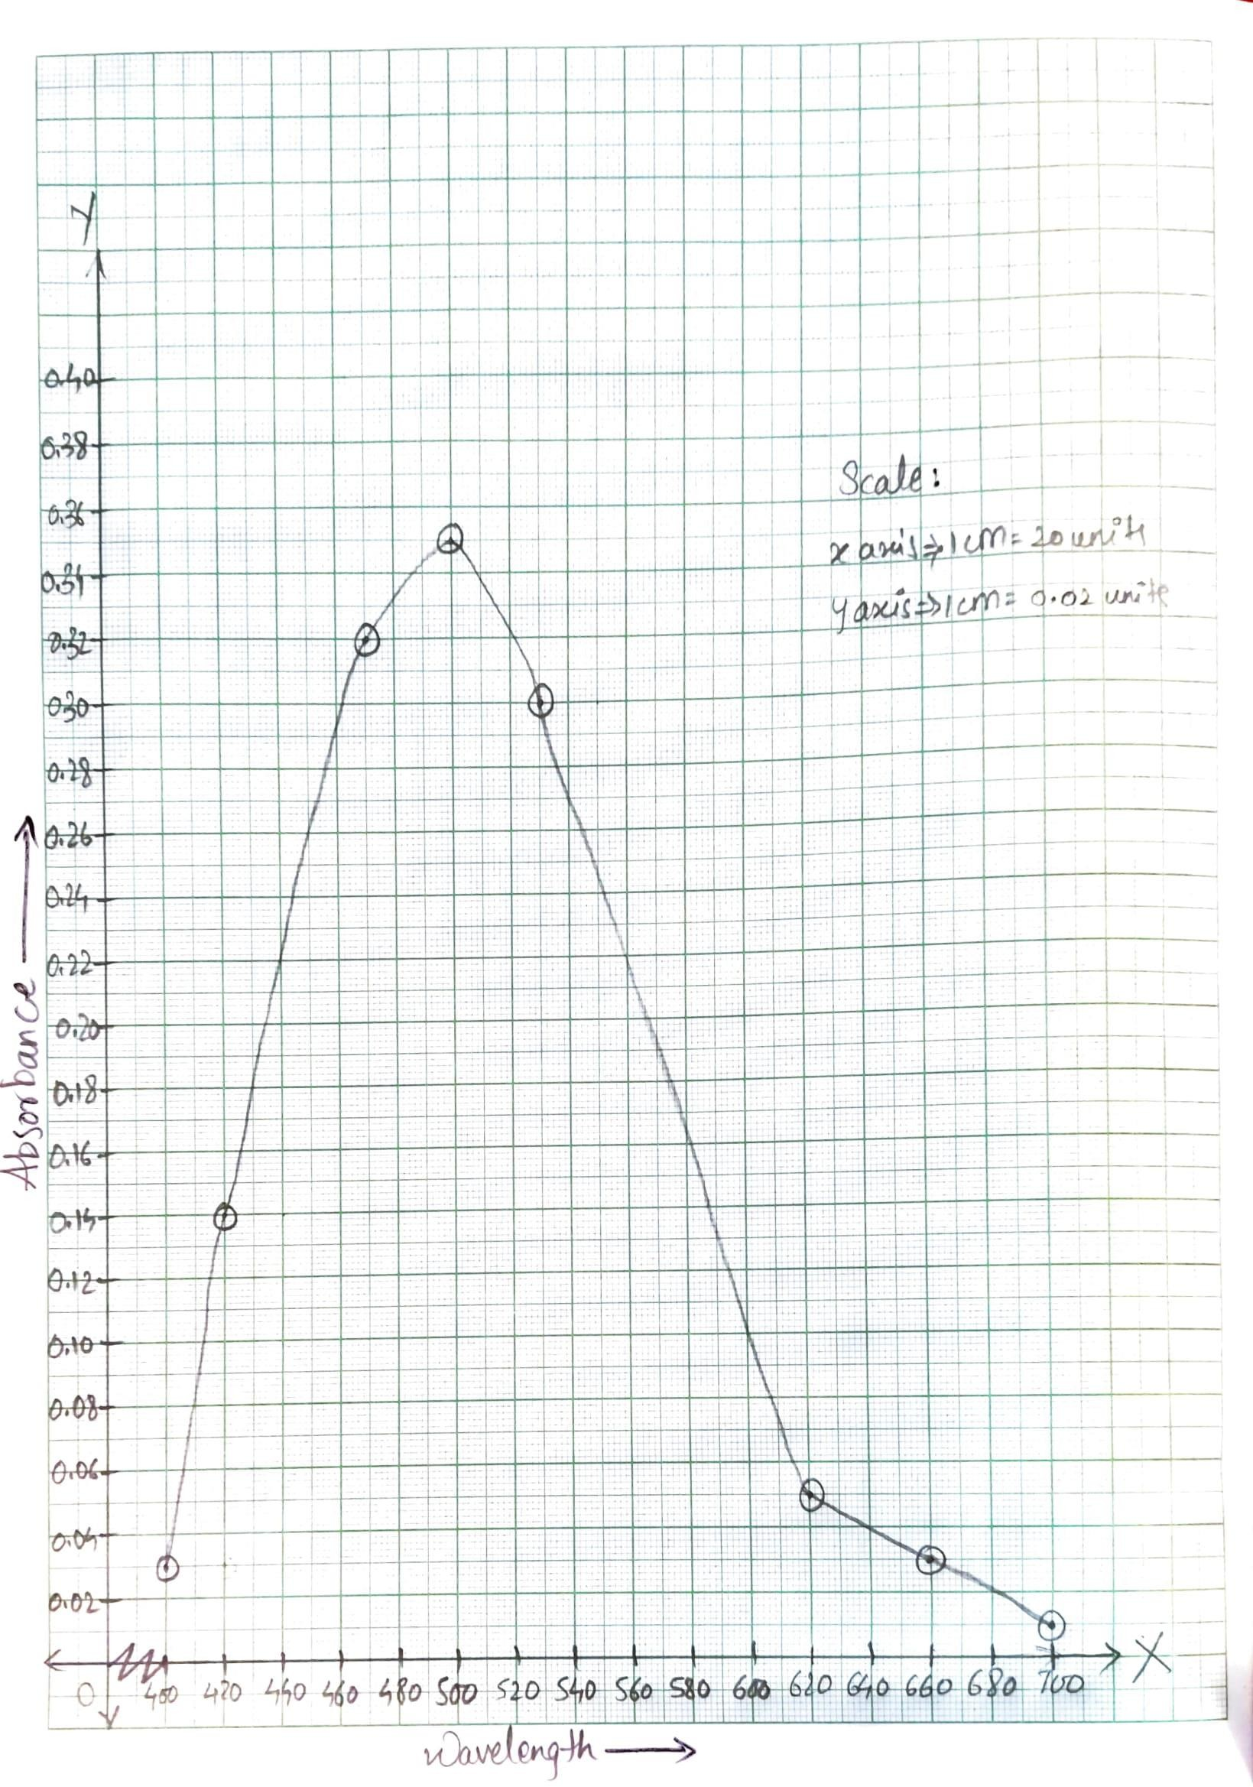

1. Determination of Unknown Concentration (2 Marks)

|  |  |  |  |  |
| --- | --- | --- | --- | --- |
| Sr. No. | Standard Fe solution | Concentration in mg/ml | (% T) | A = - Log T |
| 1. | 5 ml | 0.001 | 77 | 0.11 |
| 2. | 10 ml | 0.002 | 74 | 0.13 |
| 3. | 15 ml | 0.003 | 63 | 0.20 |
| 4. | 20 ml | 0.004 | 54 | 0.27 |
| 5. | 25 ml | 0.005 | 46 | 0.34 |
| 6. | Blank | - | (100) | 0 |
| 7. | Unknown | ? | 73 | 0.14 |

# Calculations:

Concentration of standard Fe solution = 0.01 mg/ml Using C1 V1 = C2 V2, calculate concentration of all solutions.

1. 0.01 * 5 = C2 *50

C2 = 0.001 mg/ml

2. 0.01 * 10 = C2 * 50

C2 = 0.002 mg/ml

3. 0.01 * 15 = C2 * 50

C2 = 0.003 mg/ml

4. 0.01 * 20 = C2 * 50

C2 = 0.004 mg/ml

5. 0.01 * 25 = C2 * 50

C2 = 0.005 mg/ml

Plot a graph of absorbance vs. concentration

**Graph 2: (2Marks)**

Unknown Concentration

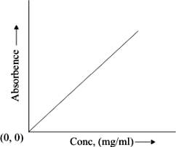

From the standard curve obtained, determine the concentration of given unknown sample.

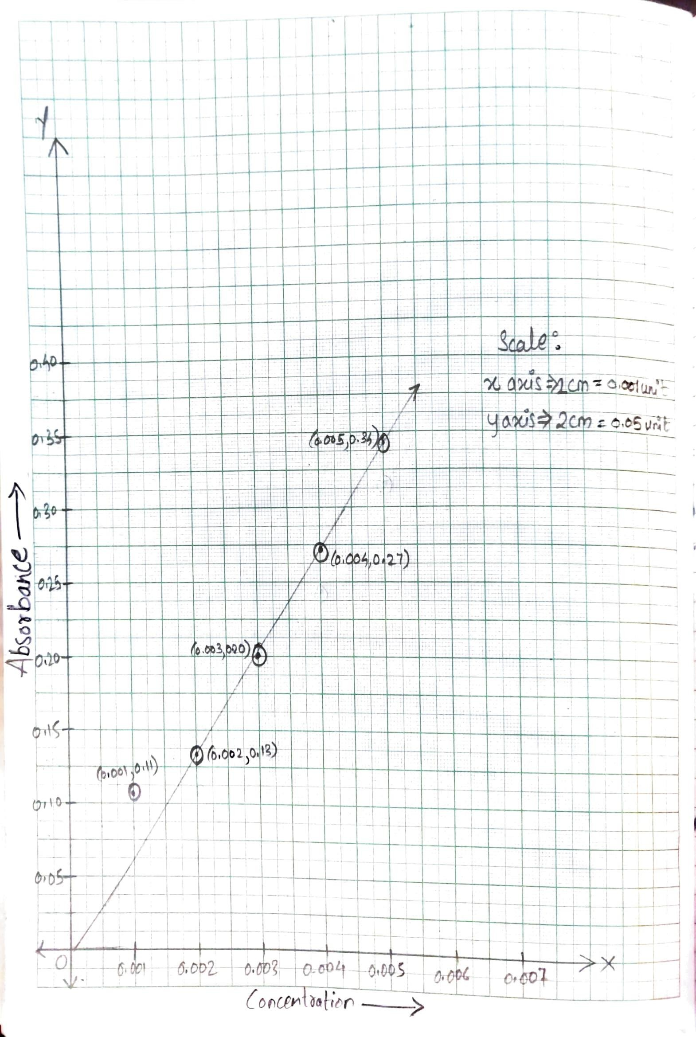

**Results: (2 Marks)**

**1) λmax = 500 nm.**

**2) Concentration of iron present in a given sample= 0.0021 mg/ml.**

**Questions (1mark)**

Q.1) State Lambert’s law and Beer’s law.

Ans) Lambert’s Law: When a beam of monochromatic light is allowed to pass through a transparent medium, the rate of decrease of radiant power with the thickness of the medium is directly proportional to the thickness of medium or the path length.

Beer’s Law: When a beam of monochromatic light is allowed to pass through a transparent medium, the rate of decrease of radiant power with the concentration of the medium is directly proportional to the radiant power i.e., absorbance of the solution is directly proportional to the concentration of the solution.